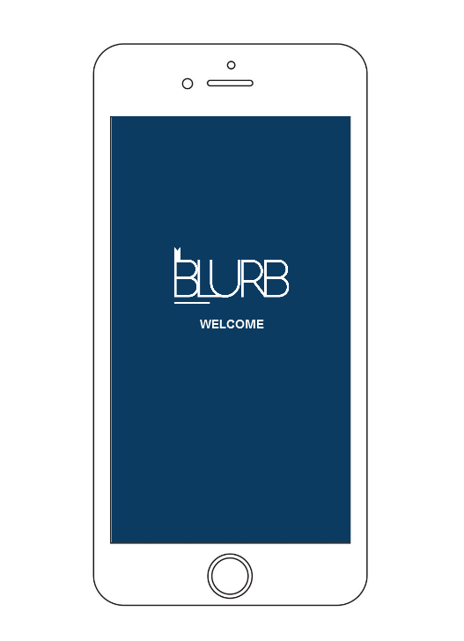

BLURP Book Retailer Report

Coursework 2

Group 5 | Mobile User Experience| 11/12/2017

# Introduction

Group 5 was consisted of 4 members as follows: Calvin Keesoony (Student 1, iPhone portrait orientation), Sam Collins (Student 2, iPhone landscape orientation), Haresh Vekryia (Student 3, iPad portrait orientation) and Madalina Voiniciuc (student 4, iPad landscape orientation).

We chose to design and implement the second concept, Book retailer Web App, as we considered it would be more challenging to develop an education related program than a fashion one. Also, after listening to some discussions within the class, we observed that most of our colleagues tend to embrace the other approach of the project so we thought it would be a good opportunity to come forward.

From the beginning we tried to establish a regularity as regards our group meetings in order to bring together our work even if each of us tried to concentrate to finish our parts and always be in time with the schedule we set.

After we received the feedback for the first coursework we decided to take into consideration the suggestions so we end up having a quite different website to the one we made prototypes for.

As regards the differences between iPhone and iPad, there are a few important ones, for example, we decided to add icons on the list of items (Stores, Events, Team Members) when the website is opened in iPad while in the iPhone device we tried to make it less crowded as there was already a lot of content to display. In the matter of orientations, the differences between iPad portrait and iPad landscape are almost not noticeable because we tried to have a sequence of the steps while doing a task on the website so that the user would not feel any discrepancy of the design unless the size of the screen is changed considerably.

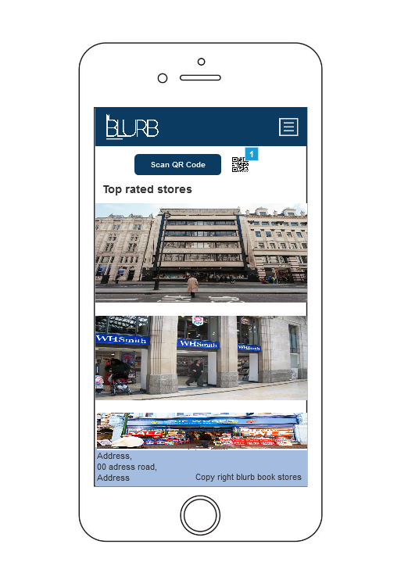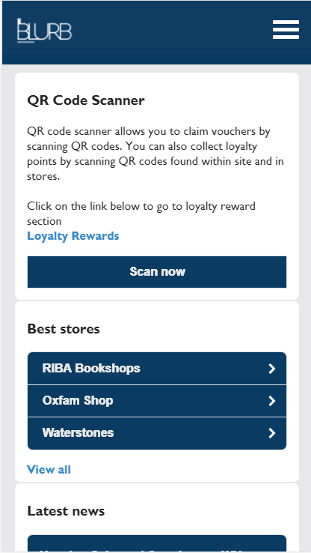

The Home page on iPhone portrait (Implemented)

The Home page on iPhone portrait (Prototype)

# Group_5_Student_1_iPhone

-

# Group_5_Student_2_iPhone

-

# Group_5_Student_3_iPad

-

# Group_5_Student_4_iPad

As student 4, I was responsible with the implementation of the proposed design for showing detailed information about team members.

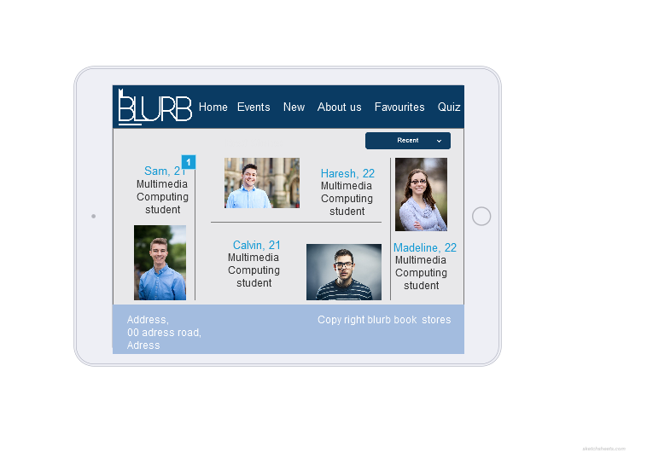.

In the prototype, the “About” section was appearing as shown in the image above. Anyway, as I started to develop the page, I found it really difficult to make it look nicely because I thought it will make the user feel confused about the structure due to the fact that there was a lot of information to be shown in one page without even using the scrolling option. So I decided to create a simple list instead consisted of 4 lines, each of them containing the photo of the team member, his name and age, level, course and his location. The same design is used for the iPad portrait, while the icons disappear when the page is displayed on iPhone, no matter the orientation. As it can be seen below, the scrolling option applies as well. In terms of sorting & filtering, I decided to use a dropdown menu in order to filter the team members by their location. The user is also allowed to sort alphabetically the team members ordering. Underneath the sorting, there is a search bar implemented using JavaScript that allows the user to type some letters in order to filter the results. It needs to be noted the fact that the searching applies to the description and location as well as to the name of the student.

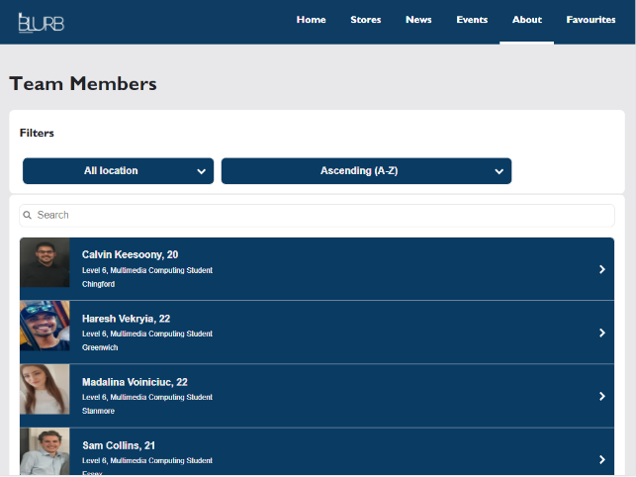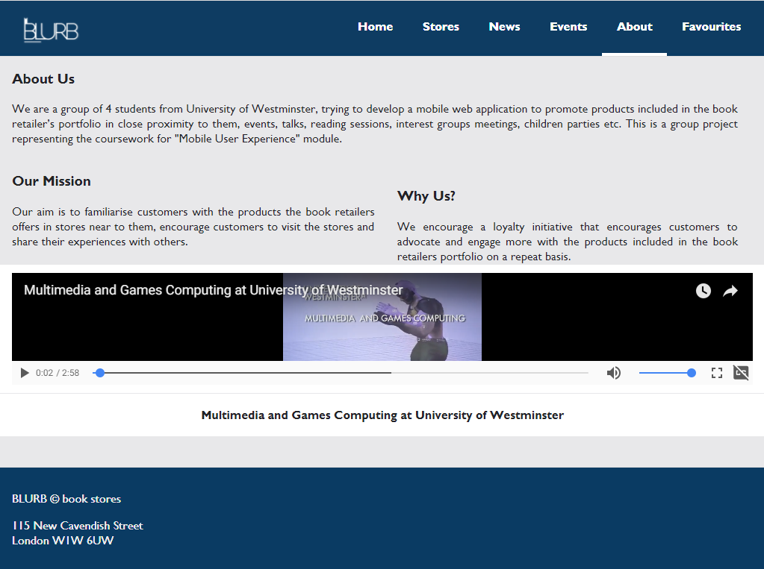

After the list of the team members I thought it would be nice to have some more information about the website so I added three paragraphs consisted into the “About Us”, “Our Mission” and “Why us?”. In the specifications I was also required to incorporate a short video so I embedded one from YouTube called “Multimedia and Games Computing at University of Westminster” so it will be related to our educational background.

The header we used was designed by Haresh (student 3) and it was used in both iPad orientations as it was simple and clear. We made it have a fixed position contrary to the footer that we thought it would make the pages look to compact.

Beside the “About” page, I was also responsible with providing a detailed information about each team member. The first idea, shown in the prototype, was changed almost completely in terms of description. I kept the name, age, picture and “Add to favorites” button though.

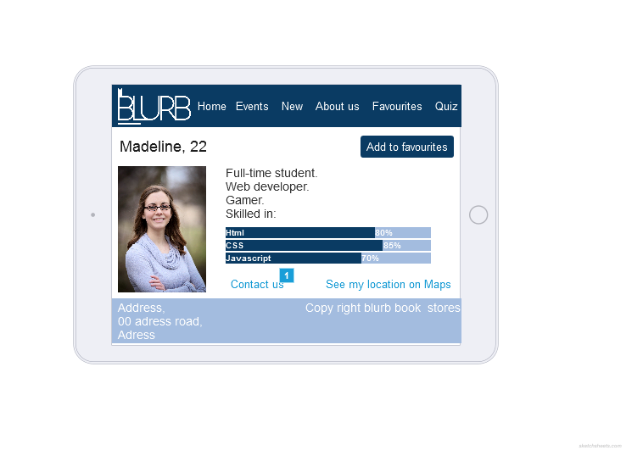

So instead of using only one capture, I implemented this page to have a clear structure and I made use of the scrolling function as well. I replaced the first description idea with a short interview that would allow the user to get to know the team member in a nicer way. Eventually, on the orientation change, the interview will go underneath the picture and the picture will expand to the screen size. Below that, there is a collapsible text saying “Click to see my location on Google Maps” so when the user clicks on that bar, the embedded map will show up allowing the user to see the location as well as to open the map in a new page, on full screen.

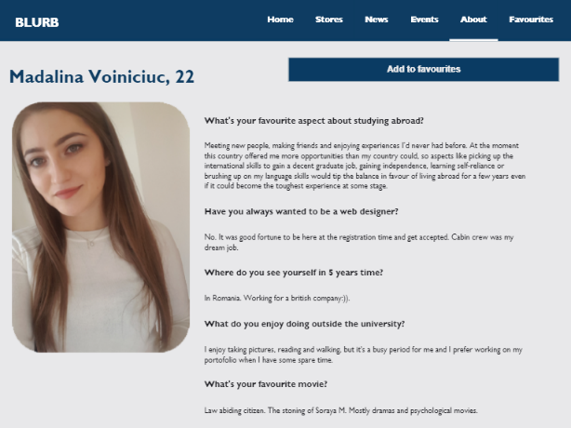 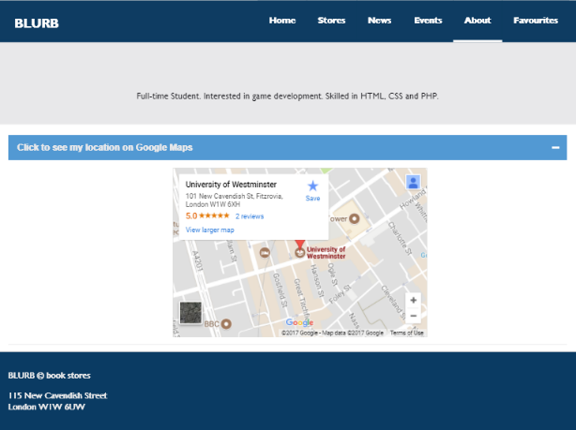

As regards the “Add to favorites” button I implemented here the system response and feedback required so when the button is clicked, a pop-up message will appear informing the user about the fact that that specific team member is added to the favorites list and is also giving him the link to the “Favorites” page. In the pictures below is shown the process of what I just explained. There is going to be one page that will contain all the favorite items around the website. At the end of that page, there is a text box asking for an email address that allows the user to send an email to himself containing the items that he added to his lists.

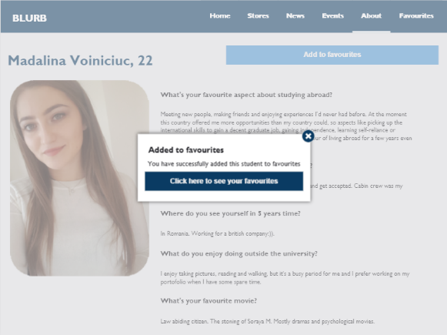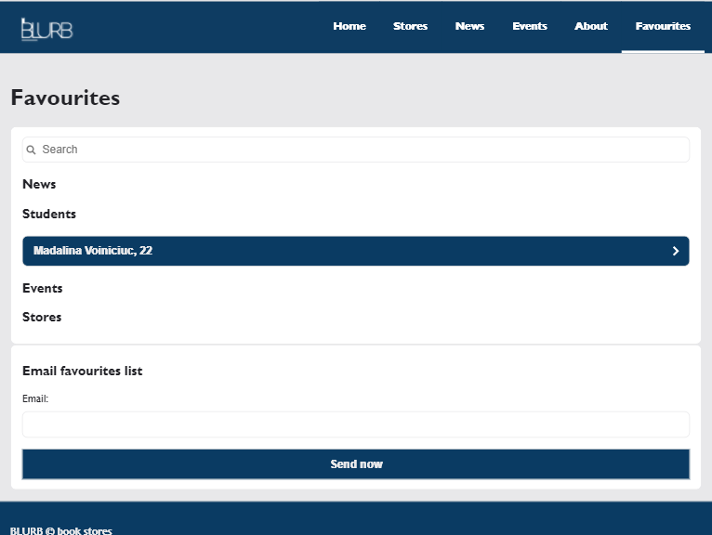

When the user clicks on the item, in this case the student, the student page will show up again, this time having the “Remove from favorites” button active. When clicked, the same pop-up message will show up announcing the user that he successfully removed the student from his favorites list.

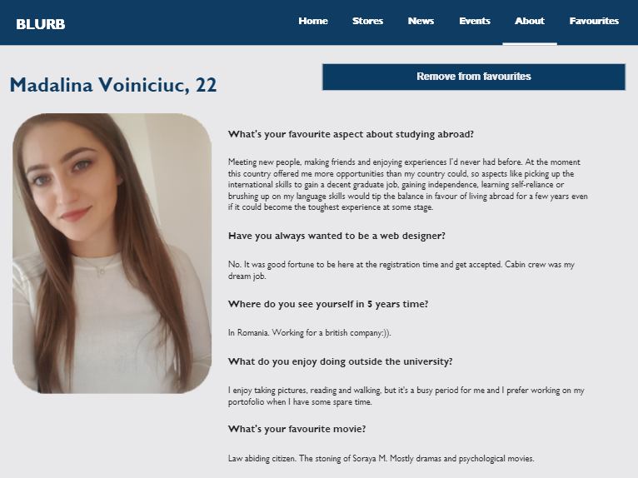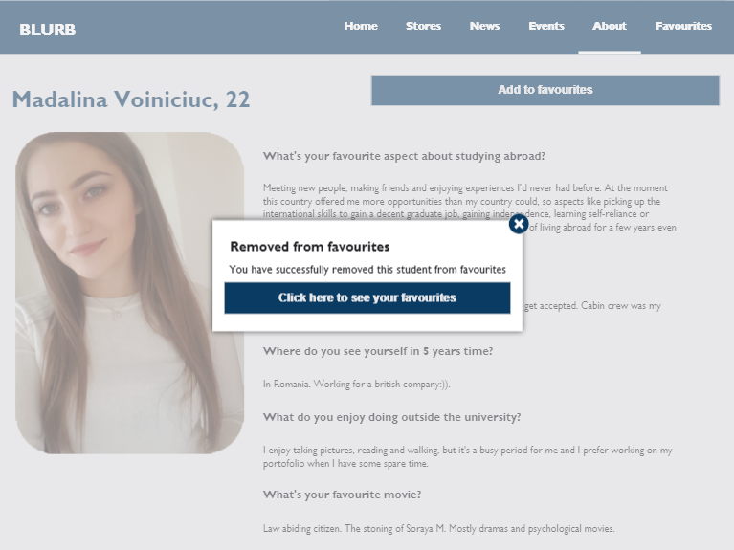

# References

# [University of Westminster](https://www.youtube.com/channel/UCDDiSoWjjf2SMnFMftaD5vg)(2014*) Multimedia and Games Computing at University of Westminster*. Available at: <https://www.youtube.com/watch?v=BaauU5K_gBo> (Accessed: 28 November 2017).